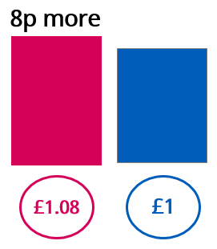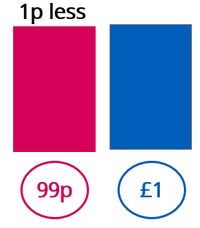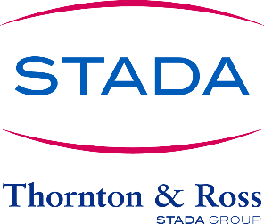

<https://gender-pay-gap.service.gov.uk/EmployerReport/nJN6qV2b/2023>

Data was taken on 5th April 2023

**54.8%**

**Lower Quartile (lowest paid)**

**64.3%**

**Lower Middle Quartile**

**Upper Middle Quartile**

**58.9%**

**Upper Quartile (highest paid)**

**51%**

**Men**

**Women**

**Proportion of women in each pay quarter**

**35.7%**

**49%**

**41.1%**

**45.2%**

At Thornton & Ross, women occupy **49%** of the highest paid jobs (an increase of **12.4% vs 2017**) and occupy **45.2%** of the lowest paid jobs.

At Thornton & Ross, **women earn 99p for every £1** that men earn when comparing median bonus pay. Their median bonus pay is **1% lower than men’s**. This is an improvement of **14.9% vs 2017**.

When comparing mean bonus pay, women’s mean bonus pay is **2.3% higher** than men.

At Thornton & Ross, **women earn £1.08 for every £1** that men earn when comparing median hourly wages. Their median hourly wage is **7.6% higher than men’s**.

When comparing mean hourly wages, women’s hourly pay is **0.6% lower** than mens. This is an improvement of **23.3% vs 2017**.

**Bonus Pay Gap**

**Hourly Wages Pay Gap**

Since 2017, the UK Government has required public and private sector employers, with 250 or more employees, to publish key data on the gender pay gap. We have reported gender pay gap figures annually in that period. Our policy is to pay all our employees in line with their level in the organisation and experience, irrespective of gender. Alongside reviewing our gender pay gap data, we perform an annual pay analysis to ensure we meet our commitment to fair pay.

Over the past seven years, we have focused on our business processes and compensation and benefits strategy which has resulted in significant improvements in the gender pay gap in our organisation. In that time, the median pay and bonus pay gaps have both improved by 21.5% and 14.9% respectively. We continue to see year on year improvement in these figures, demonstrating our commitment to fair and supportive working conditions.

At STADA we embrace diversity and inclusion, and this year’s results highlight the continued improvement in gender diversity across our organisation. Over 49% of women work in our highest paying positions, an increase of 12.4% in the last six years.

Our commitment to developing a sustainable and inclusive workforce with fair and supportive working conditions, stems from our purpose of **Caring for People’s Health as a Trusted Partner**. Giving our best to ensure strong business growth with a positive impact on people, aligns with our four corporate values of **Integrity**, **Agility**, **Entrepreneurship** and **OneSTADA**.



**Thornton & Ross**

Gender Pay Report 2023/24